The Biopharmaceutical Analysis Training Laboratory (BATL)

Committed to Global Regulatory Convergence
in the Fight Against COVID-19

A critical mission in the U.S. and around the world is ramping up the number of tests for COVID-19 that can be processed quickly and accurately. The Biopharmaceutical Analysis Training Laboratory (BATL) at Northeastern University stands ready to train the workforce at these testing sites and respond to other needs of the healthcare and biopharmaceutical industries.

The Biopharmaceutical Analysis Training Laboratory was created to improve patient access to safe healthcare products and health security. It has served as a vital source for training in compliance with regulations of pharmaceutical, biopharmaceutical, and other related health products for nearly a decade. Whether training those just entering the workforce or reskilling and upskilling learners from any walks of life, BATL is there with both hands-on and virtual training solutions to respond to the needs of industry, academia, and governments worldwide.

Building Capacity to Meet Emerging Needs
BATL is recognized by the Asia-Pacific Economic Cooperation, the International Council for Harmonisation, the Pharmaceutical Research and Manufacturers of America, and the World Health Organization as a neutral, global facilitator of collaboration between academia, industry, and government all working toward regulatory convergence.
A Clear Vision, an Urgent Mission

BATL strives to enable workforce training alongside global medical regulatory convergence in an effort to assist in accelerated drug approvals and ultimate drug access for patients.

Our diverse, innovative, and globally recognized experiential learning and credentialing programs offer a neutral platform to train the industry’s workforce while also converging the intricacies of global regulatory considerations for pharmaceutical and biopharmaceutical products. In doing so, we increase the potential of accelerated drug approvals with quality, safety, and efficacy at the forefront, thus impacting patients for improved access to medicines worldwide.

As a trusted partner within this wide collaborative network of international and regional regulatory authorities, industry, nongovernmental organizations, and academic institutions, BATL is playing a leadership role in contributing to regional capacity-building and systems-strengthening initiatives. At no time has this role been more important than during the COVID-19 pandemic sweeping the globe.

With the need for testing becoming more urgent each day, there will be an influx of new employees who will need to learn to properly conduct COVID-19 testing. Industry partners can utilize BATL to develop and deploy virtual trainings to meet their specific needs around DNA/RNA or protein-based testing.

A Proven Record of Partnerships
During these uncertain times, instrumentation and pharmaceutical companies must be innovative and nimble in crafting solutions to diagnose and treat COVID-19. BATL has a proven track record of partnering with such companies to help them achieve their workforce development goals.

BATL works closely with several instrumentation companies, including Thermo Fisher Scientific, Agilent We help our partners get their workforces up to speed when using new instrumentation, such as new COVID-19 testing equipment. BATL also assists biopharmaceutical corporations, including Biogen, Roche-Genentech, Pfizer, and Amgen in similar pursuits. And our Burlington, MA-based campus has more than 20,000 square feet of space available immediately—contiguous with BATL’s space—as a potential additional test processing location, if needed.

Training is our business, and we stand ready to help. The lab employs a Microsoft HoloLens to provide enhanced virtual training that allows us to teach up to 100 students in their home or at a training site. BATL can provide virtual teaching and training via video that can be distributed globally to testing and processing sites to increase the availability of skilled workforce to process tests. We can also help industries quickly reposition workers being laid-off from other industries, skilling them for careers in biopharmaceutical testing.
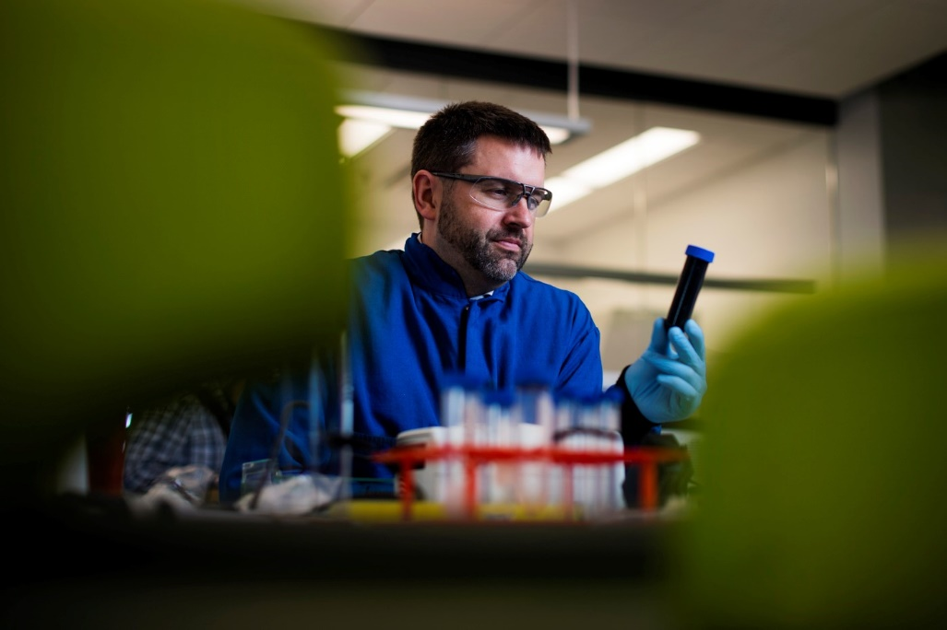
“The role of BATL is training, and we stand ready to train a robust workforce to handle COVID-19 testing. Through our efforts at BATL, we can ensure that patients around the world get the diagnoses they need to survive—and thrive—as quickly and safely as possible.”

—Jared R. Auclair, Associate Teaching Professor; Director, the Biopharmaceutical Analysis Training Laboratory; and Director, Bioinformatics Programs, Northeastern University
About Northeastern
Northeastern University is a global research university and recognized leader in experience-powered lifelong learning, and we are reinventing higher education for a fast-changing global economy. Our global university system—a network of campuses, research partners, faculty, alumni, and employers—makes learning and innovation flexible and customizable, meeting learners where they are anywhere at any time.

Our locations—in Boston and the Massachusetts communities of Burlington (BATL) and Nahant; Charlotte, NC; the San Francisco Bay Area; Seattle; Toronto; Vancouver; and London—are nodes in our growing global university system. The Roux Institute is Northeastern’s new graduate education and research center located in Portland, Maine, focused on an increasingly critical field: experiential artificial intelligence.

Through this extensive network, we expand opportunities for flexible student learning and collaborative, solution-focused research. Northeastern University is committed to delivering cutting-edge programs that foster interdisciplinary thinking, research, and the pursuit of innovation-driven discoveries that have a positive impact on society. Individuals with advanced scientific knowledge, intellectual flexibility, drive, and professional skills can benefit from Northeastern’s unique experiential approach to pursue paths of innovation with the potential to save lives.

Contact Us
Faculty Expert: Jared Auclair, Director of Biotechnology and Bioinformatics, Associate Teaching Professor, Director, Biopharmaceutical Analysis Training Laboratory Executive Director j.auclair@northeastern.edu

Fundraising Contact: Patty Flint, Assistant Vice President for Interdisciplinary Initiatives p.flint@northeastern.edu

